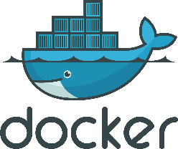
Docker Basic – Training Course.
Duration: 5 Hours

Are you new to Docker? This Docker Basic Training Course is made just for beginners. Here, you’ll learn what containers are and how Docker helps you create, use, and manage them. Step by step, we’ll go over the basics and show you how to run simple apps with Docker. By the end, you’ll see how Docker makes it easy to build and share your projects. Let’s get started!

Course Content:
- Setting up the stage.
  - Monolithic vs Microservice Architecture.
  - Issues before containerization.
  - What is container?
  - Container vs Virtual Machine.
  - Different containerization tools.
  - Why Docker?

- Docker Introduction.
  - Docker overview.
  - Docker installation.
  - Getting started with Docker.

- Docker Architecture.
  - Docker CLI.
  - Docker Host.
  - Docker Engine.
  - Docker Object.
  - Docker Registry.

- Docker basic commands.
  - Basic docker commands like docker run, docker ps, docker inspect, docker delete, docker images etc.

- Docker Storage.
  - Volumes.
  - Bind Mount.
  - Tmpfs Mount.
  - Storage Drivers.
- Docker Networking.
  - Bridge Network.
  - Host Network.
  - Overlay Network.
  - Macvlan Network.
  - None Network.

- Docker Image.
  - Dockerfile.
  - Dockerfile Instructions.
  - Dockerfile best practice.
  - Docker multi-stage build.
  - Docker Registry.

- Docker Compose.

- Docker Orchestrator Tools.
  - Docker Swarm.
  - Kubernetes.
  - AWS ECS.
  - AWS ECR.

- Docker Enterprise Edition.

- Docker Trusted Registry.

